

**Second Hand Safe**

***Brand and Model: Chubb Europa Grade III Size 2***

Type of safe: 100K Cash Rated theft resistant Safe

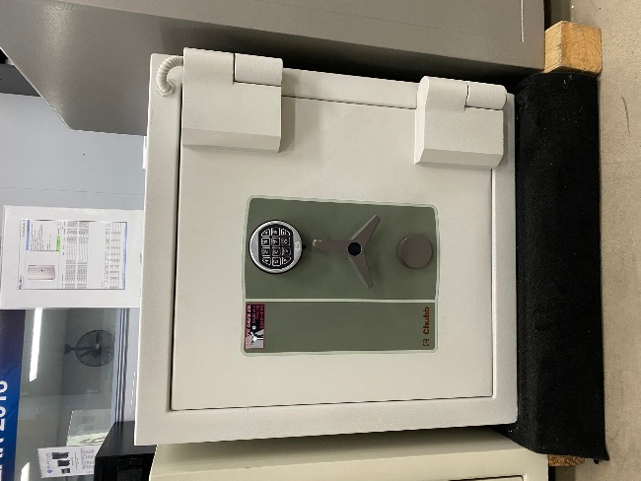 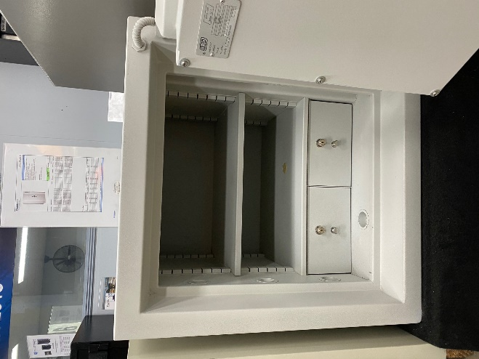 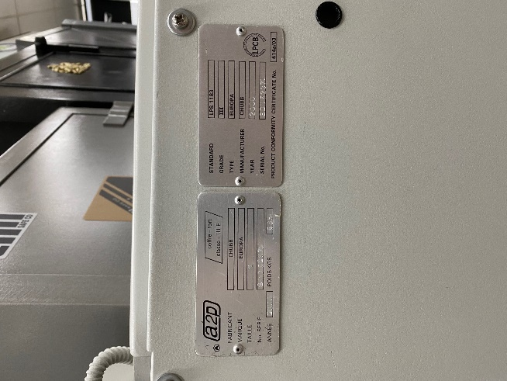

External dimensions: Height 720 mm, Width 670 mm & Depth 670 mm (Plus 50mm for door handle)

Internal dimensions: Height 390 mm, Width 500 mm & Depth 420 mm

Draws: 140mm high with key locks

External locking features:

* Digital code access lock and Key Lock

Internal features:

* 1 x adjustable shelves
* 2 x lockable draws

Price $2950.00 Plus G.S.T

* Same warranty as New unit – 12 months
* Fully servicing of all locks and mechanism
* 2 keys for main door and each lockable draw
* Not inclusive of any freight charges





Unit 16 47-51 Little Boundary Rd Laverton North, Vic 3026

Ph: 1800 01 91 71 Fax: +61 3 9318 9877

**Email: sales@abatesafe.com.au**