Second Hand Safe
Brand and Model: Bentley Fortress

Type of safe: 250K Cash Rated theft resistant Safe

External dimensions: Height 750 mm, Width 710 mm & Depth 725 mm (Plus 50mm for door handle)

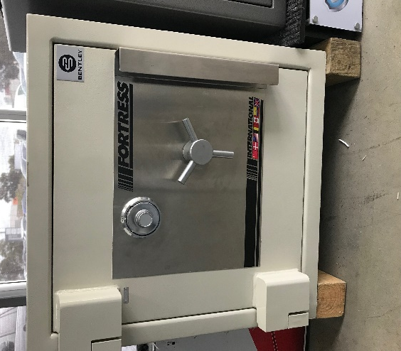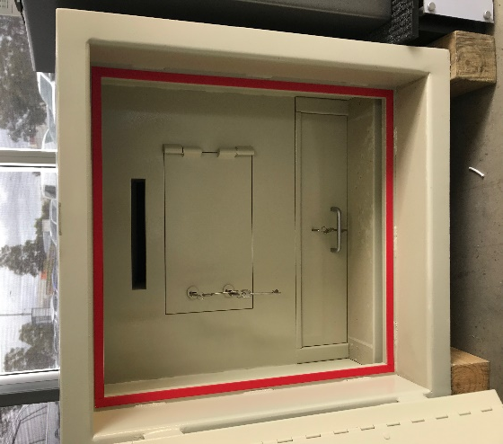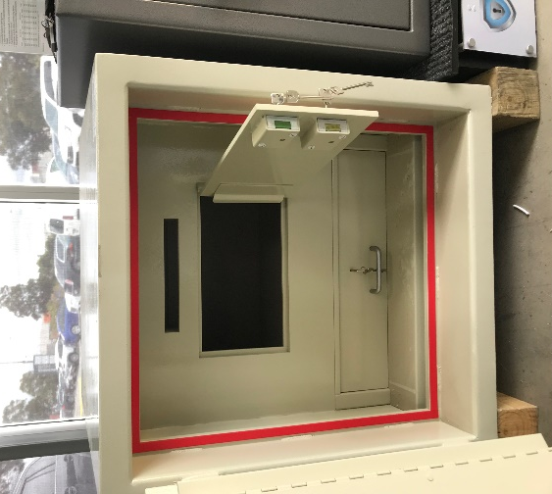

External locking features:

- 4 wheel combination lock

Internal features:

- 1 x deposit slot with dual key locking door
- 1 x lockable roll out draw

This is inclusive of:

- 12 month warranty
- Fully servicing of all locks and mechanism
- 2 keys for all locks

Total price for supply, delivery and installation is $4950.00 Plus G.S.T

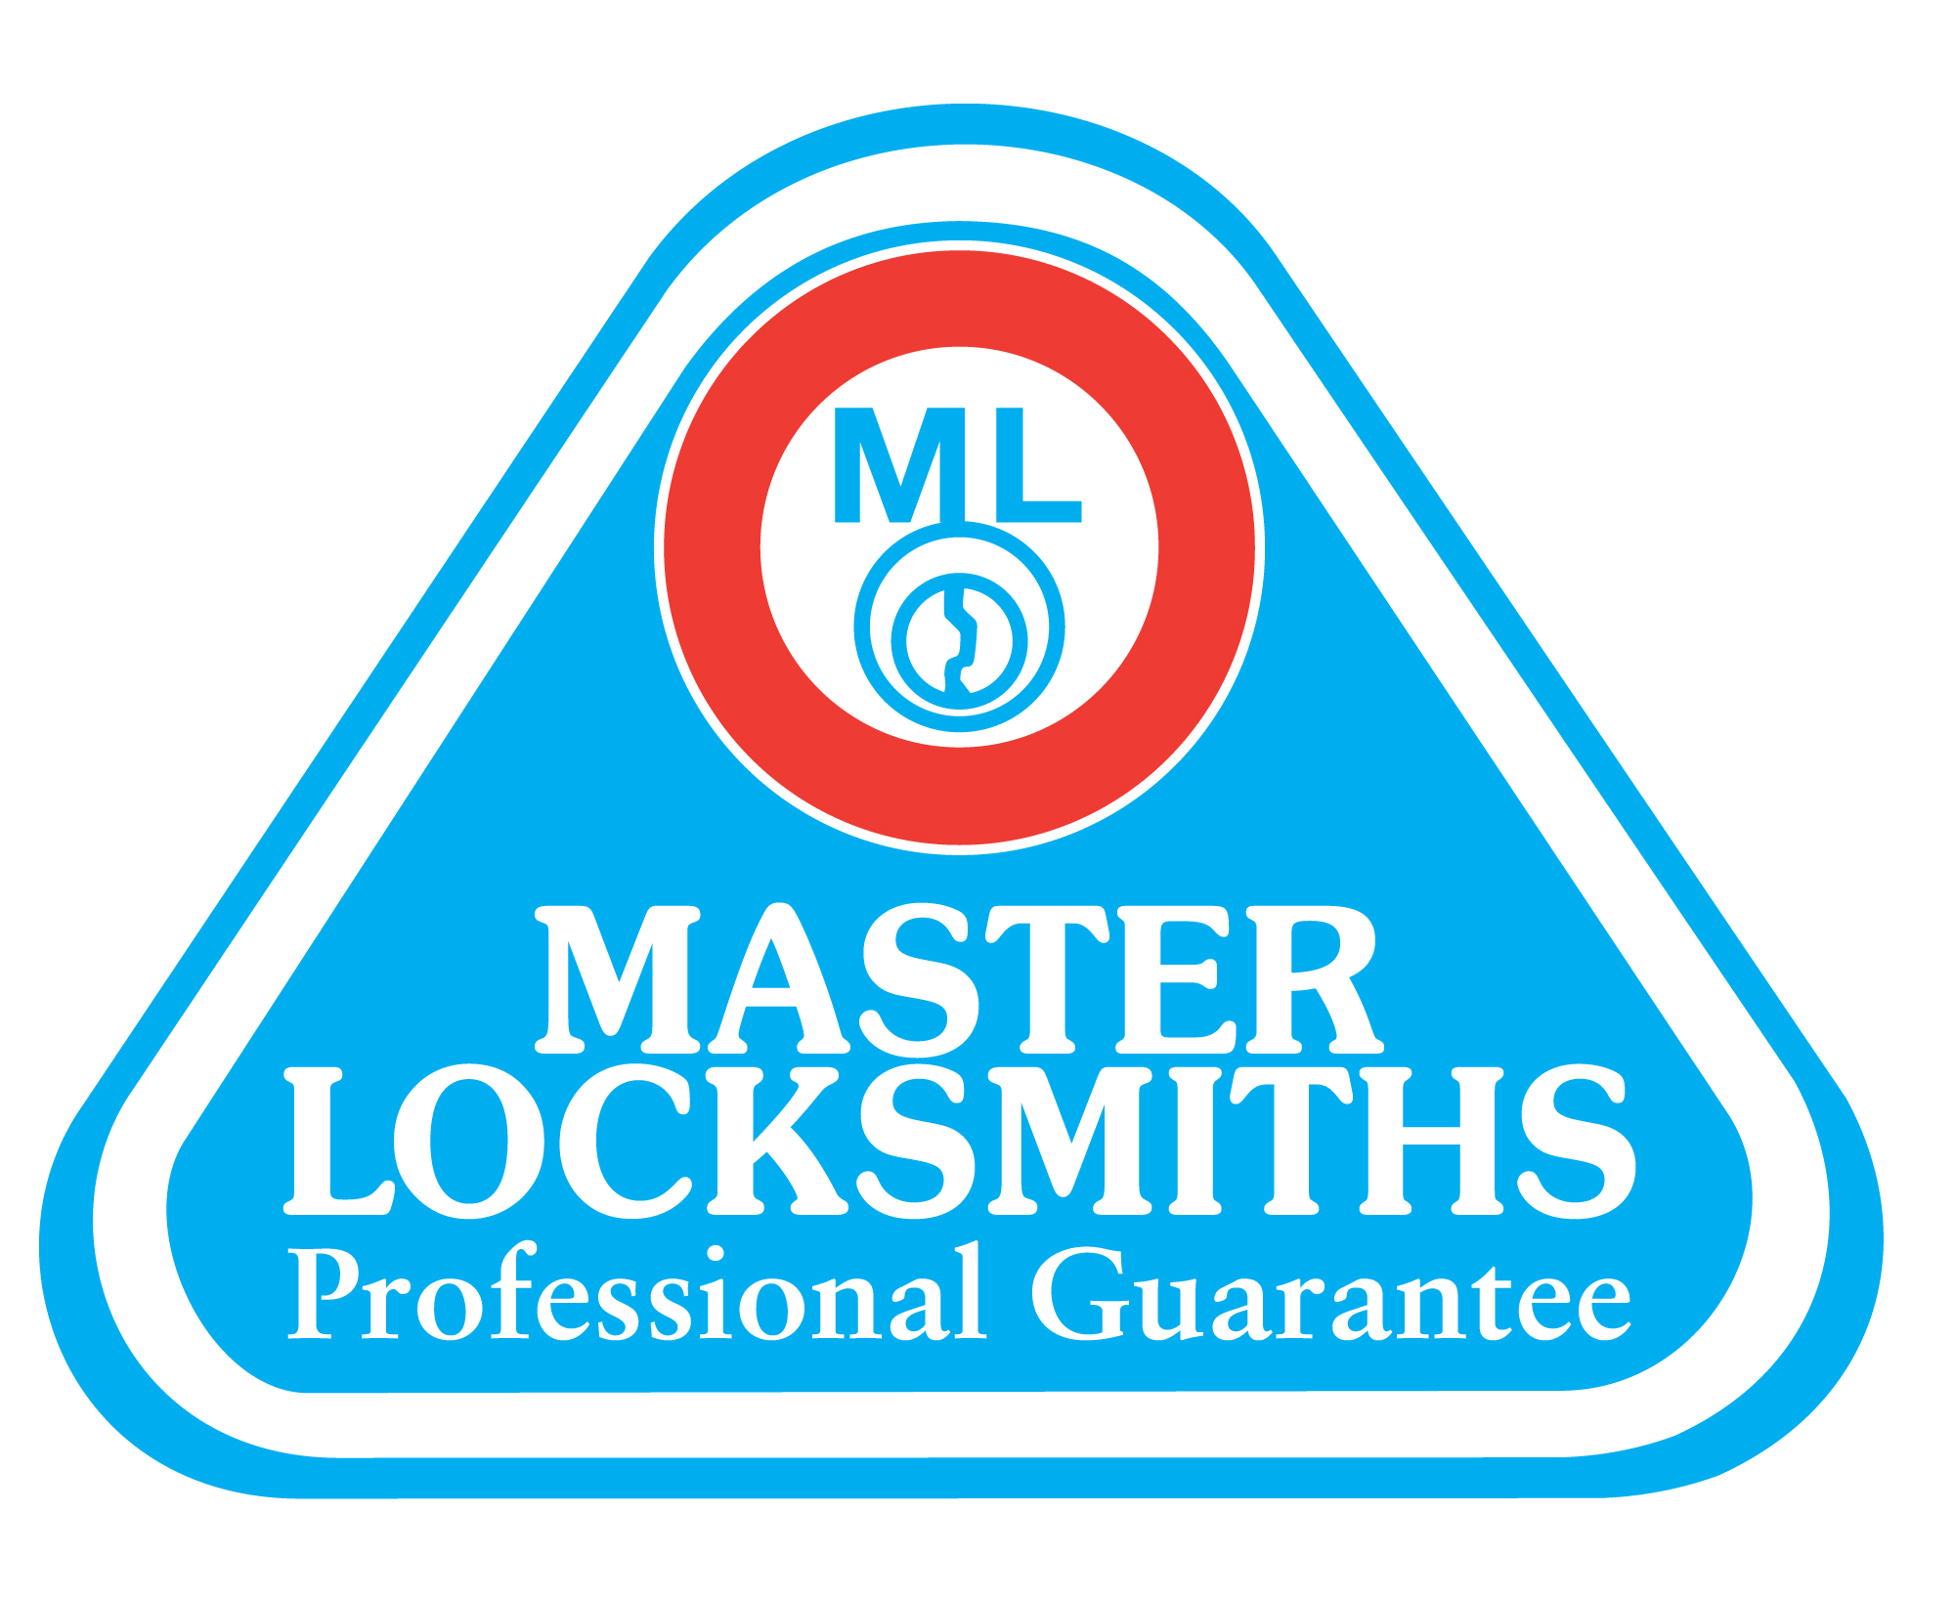
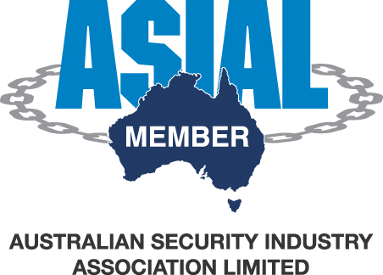
Unit 16 47-51 Little Boundary Rd Laverton North, Vic 3026
Ph: 1800 01 91 71 Fax: +61 3 9318 9877
Email: sales@abatesafe.com.au

